This Guide outlines how to verify that the FLIR sensor inside the 6x thermal and 6x Thermal Pro are Programmed correctly.

- Download QGIS from here: https://qgis.org/download/
  - Click on "Latest version for Windows (3.44)" for download
  - Open the downloaded file and complete the installation process.
- Take a picture of a wall with the thermal imager from about 3 feet away. Make sure the wall is room temperature and the camera is square to the wall when taking the picture
- Transfer this image to your computer
- Open QGIS
- Drag and drop the image from step 3 into QGIS.
- Click on the info tab as shown
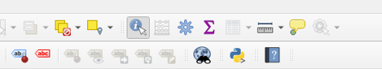
- Click somewhere in the middle of the image. A red dot should appear where you clicked. You should now see something like the image below:
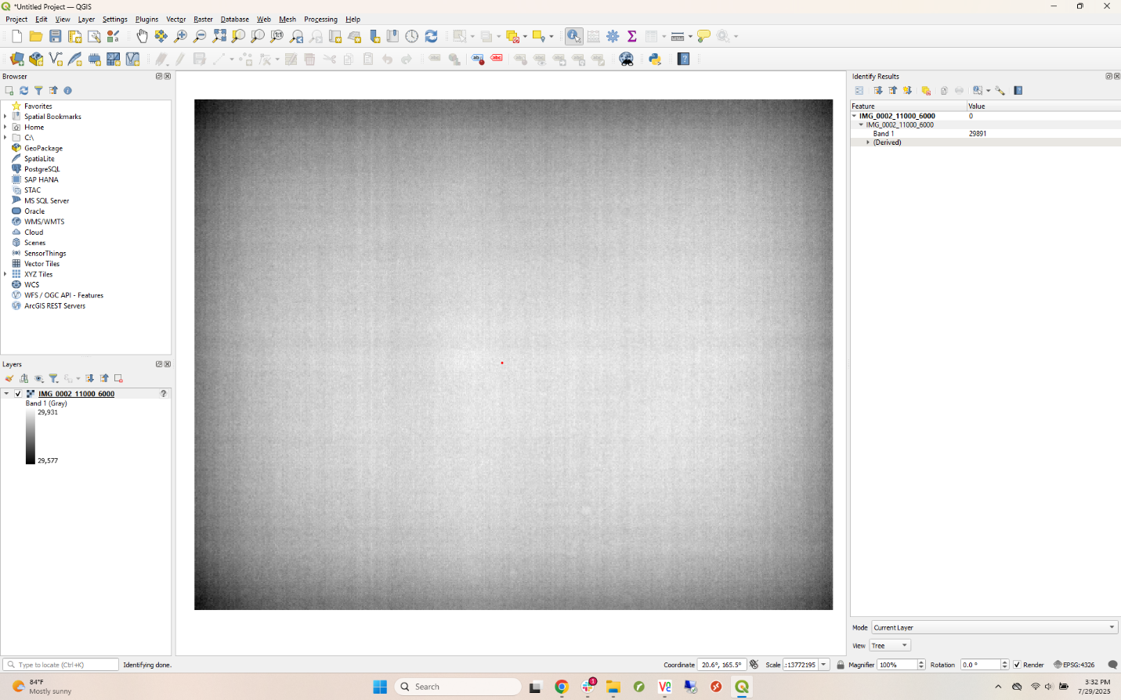
In the pane on the right, you should now see some information about the image.
- Check the value to the right of “band 1”
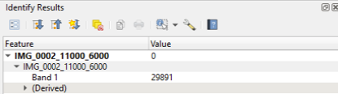
This value must be between 29115 and 30015
- Screenshot QGIS and upload your screenshot to taurus with the rest of the 6x data.

